Trp operon (Trytophan operon)
Many genes for amino acid biosynthetic enzymes are regulated by transcription Attenuation.
The genes for the enzymes needed to synthesize a given amino acid are generally clustered in an operon and are expressed whenever existing supplies of that amino acid are inadequate for cellular requirements. When the amino acid is abundant, the biosynthetic enzymes are not needed and the operon is repressed.
The E. coli tryptophan (trp) operon (Fig. 1) includes five genes for the enzymes required to convert chorismate to tryptophan. Note that two of the enzymes catalyze more than one step in the pathway. The mRNA from the trp operon has a half-life of only about 3 min, allowing the cell to respond rapidly to changing needs for this amino acid.
The Trp repressor is a homodimer, each subunit containing 107 amino acid residues. When tryptophan is abundant it binds to the Trp repressor, causing a conformational change that permits the repressor to bind to the trp operator and inhibit expression of the trp operon. The trp operator site overlaps the promoter, so binding of the repressor blocks binding of RNA polymerase.

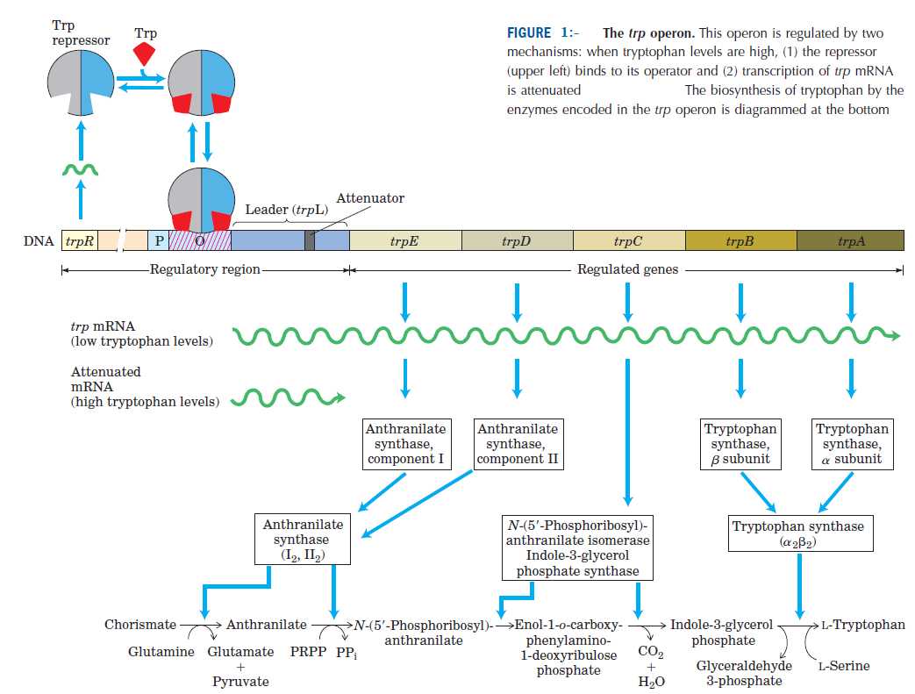
- Different cellular concentrations of tryptophan can vary the rate of synthesis of the biosynthetic enzymes over a 700-fold range.

- Once repression is lifted and transcription begins, the rate of transcription is fine-tuned by a second regulatory process, called transcription attenuation, in which transcription is initiated normally but is abruptly halted before the operon genes are transcribed.

- The frequency with which transcription is attenuated is regulated by the availability of tryptophan and relies on the very close coupling of transcription and translation in bacteria.

- The trp operon attenuation mechanism uses signals encoded in four sequences within a 162 nucleotide leader region at the 5_ end of the mRNA, preceding the initiation codon of the first gene (Fig. 2a).

- Within the leader lies a region known as the attenuator, made up of sequences 3 and 4. These sequences base-pair to form a GC-rich stem-and-loop structure closely followed by a series of U residues. The attenuator structure acts as a transcription terminator (Fig. 2b).

- Sequence 2 is an alternative complement for sequence 3 (Fig. 2c). If sequences 2 and 3 base-pair, the attenuator structure cannot form and transcription continues into the trp biosynthetic genes; the loop formed by the pairing of sequences 2 and 3 does not obstruct transcription.

- Regulatory sequence 1 is crucial for a tryptophan sensitive mechanism that determines whether sequence 3 pairs with sequence 2 (allowing transcription to continue) or with sequence 4 (attenuating transcription).

- Formation of the attenuator stem-and-loop structure depends on events that occur during translation of regulatory sequence 1, which encodes a leader peptide (so called because it is encoded by the leader region of the mRNA) of 14 amino acids, two of which are Trp residues.

- The leader peptide has no other known cellular function; its synthesis is simply an operon regulatory device.

